MODULE 1
1. Create a file and add executable permission to all users (user, group and others
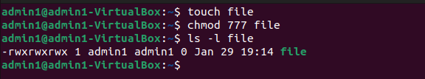
2. Create a file and remove write permission for group user alone.
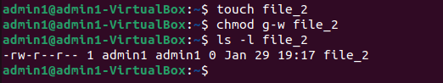
3. Create a file and add a softlink to the file in different directory (Eg : Create a file in dir1/dir2/file and create a softlink for file inside dir1)
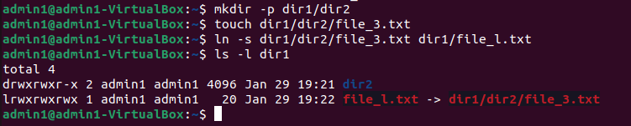
4. Use ps command with options to display all active process running on the system
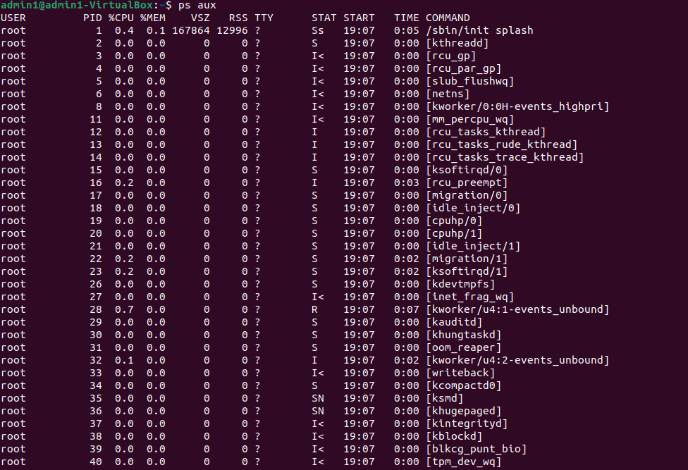

5. Create 3 files in a dir1 and re-direct the output of list command with sorted by timestamp of the files to a file
